NEW CUSTOMER PAGE

Open Guru99 demo site page using URL and login with user name and password .

Select bank page .

Click on new customer.

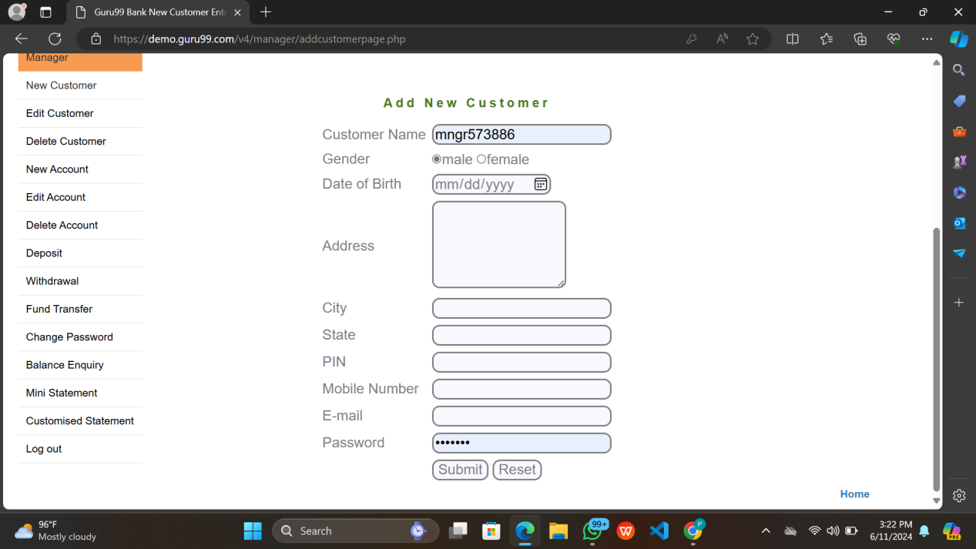

TC_001 :- Validating new customer page by giving EMPTY INPUTS .

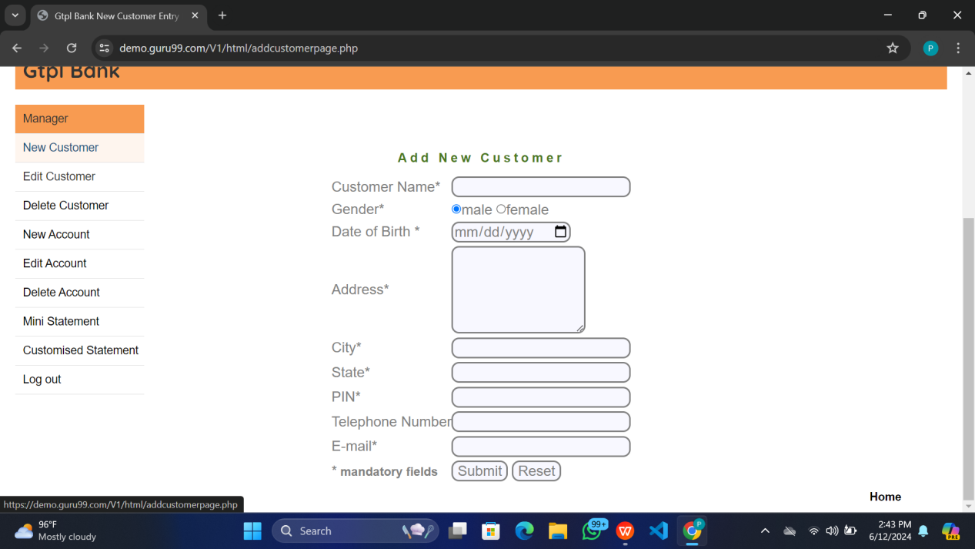

Expected result : Error message should be displayed .

ACTUAL RESULT:-

Error message :- Please fill all the details.

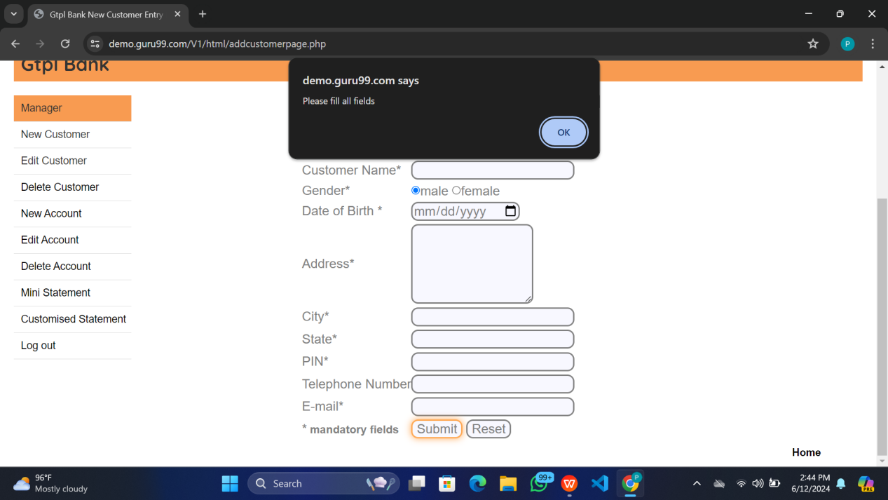

TC_002 :- Validating the new customer page by giving invalid customer name Expected result : Error message should be displayed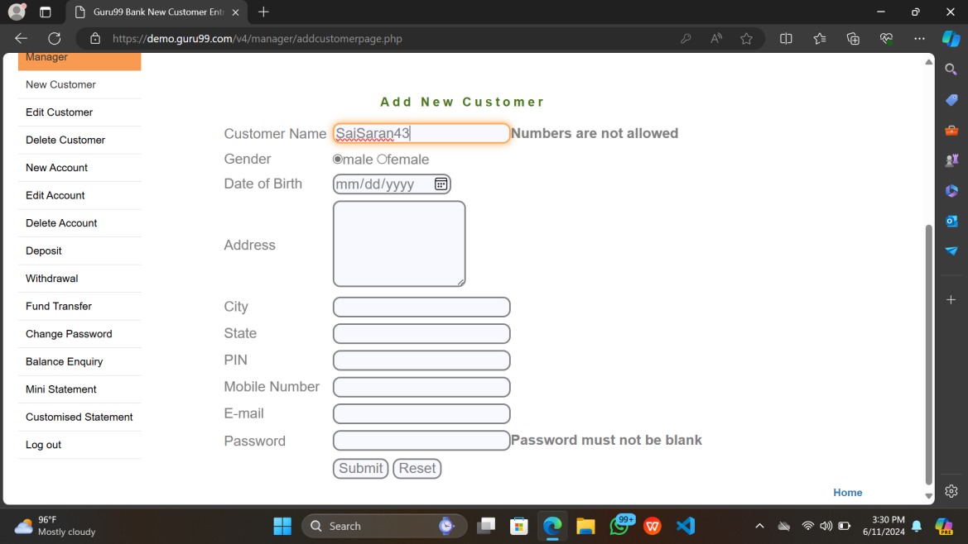

Actual Result :- Numbers aren’t allowed

After clicking on submit button :-

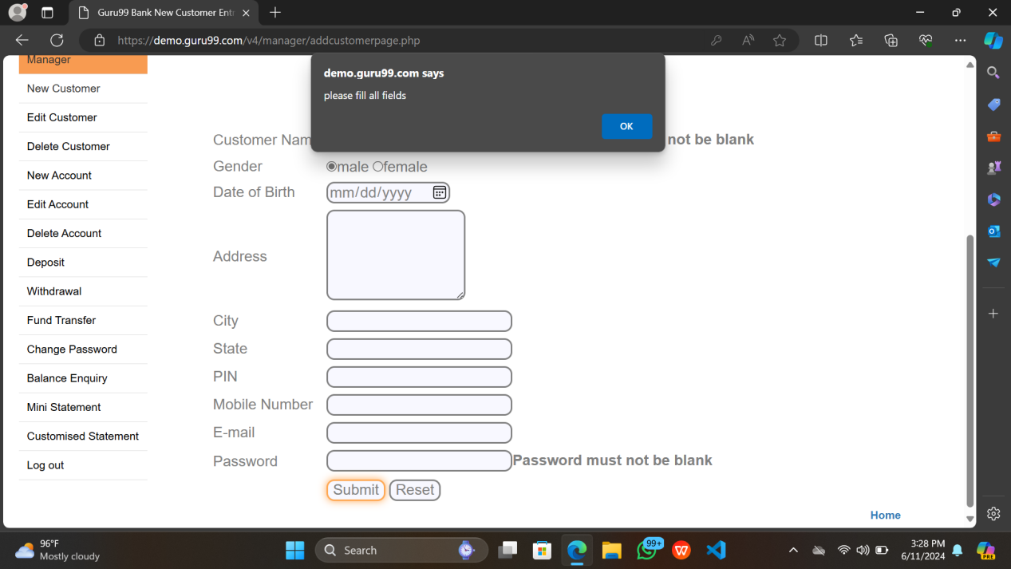

Error message :- Please fill all the details .

TC_003 :- Validating the new customer page by giving invalid customer name along remaining valid inputs

Expected result :- Error message should be displayed .

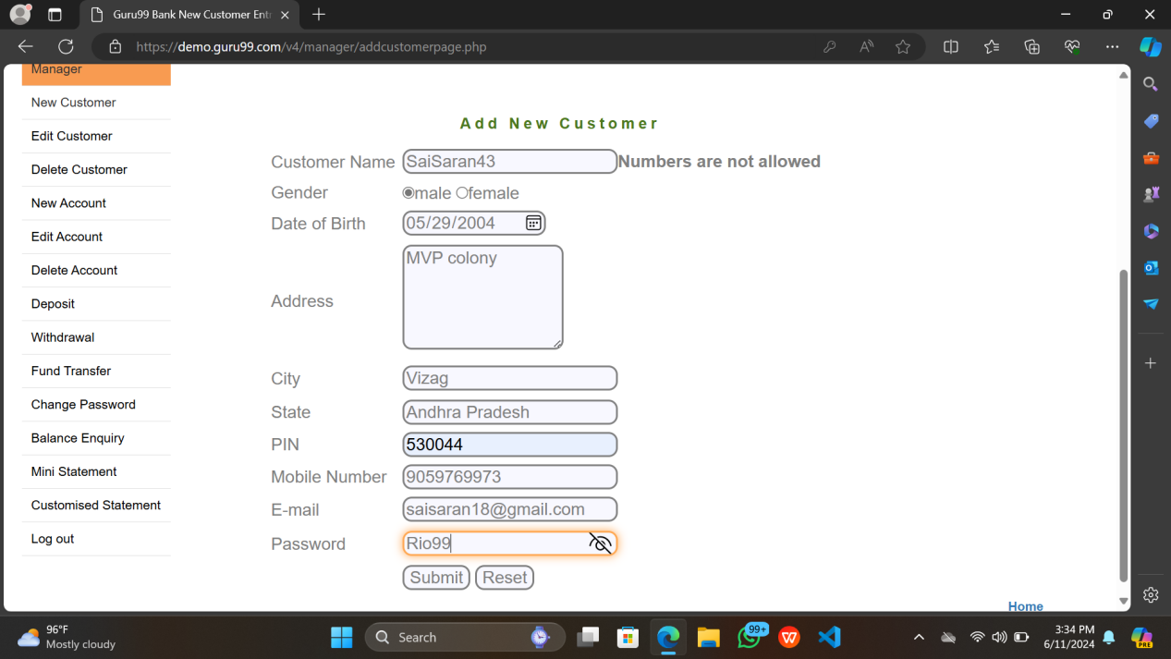

Actual Result :- Numbers aren’t allowed

Error message :- Please fill all the details .

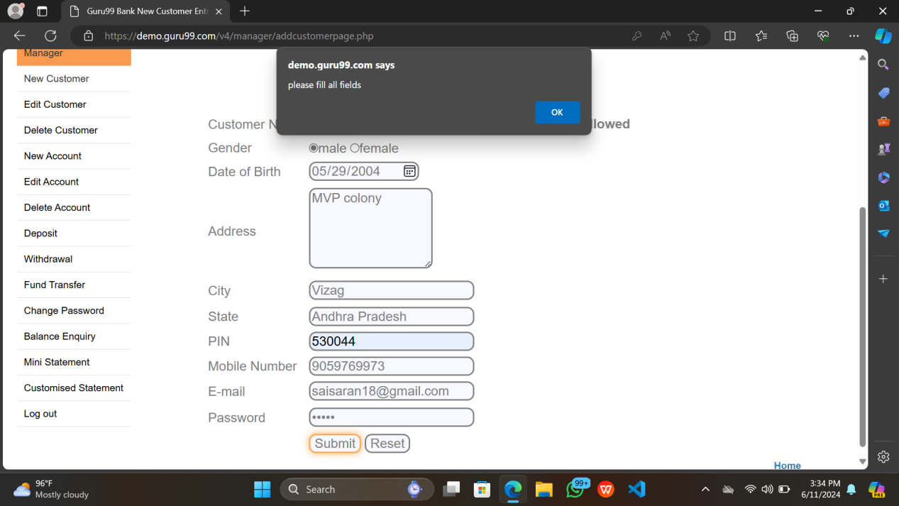

Comment :- The error message should be given as the customer name is invalid .

TC_004 :- Validating the new customer page by giving invalid STATE

Expected result :- Error message should be displayed .

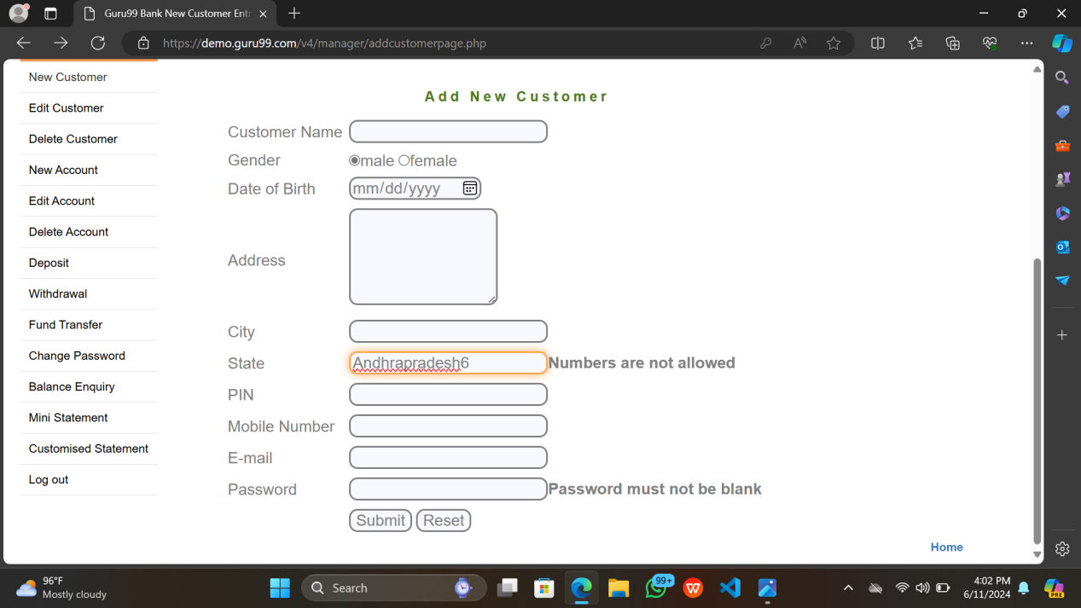

Actual Result :- Numbers aren’t allowed

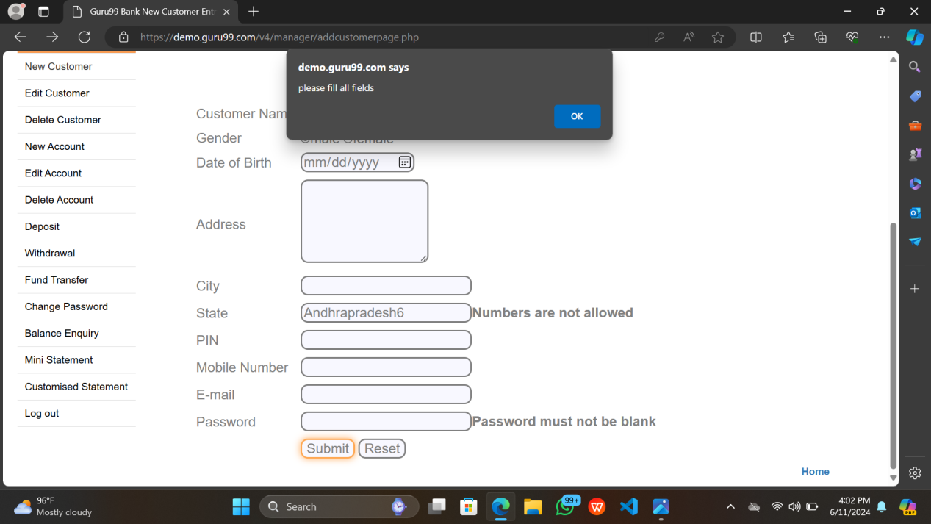

Error message :- Please fill all the details .

TC_005 :- Validating the new customer page by giving invalid STATE and PIN

Expected result :- Error message should be displayed .

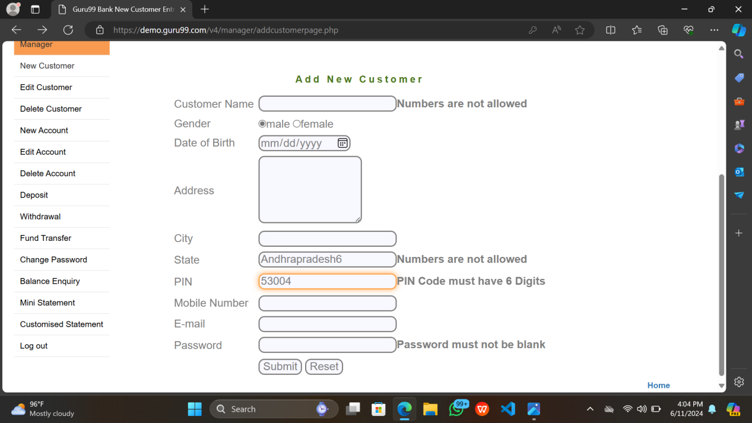

Actual Result :- Numbers aren’t allowed

Pin-code must have 6 digits

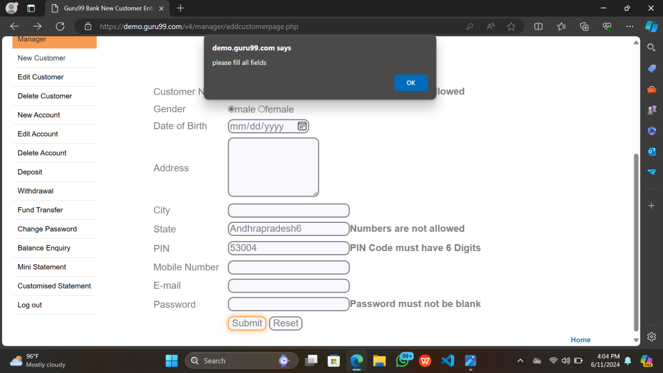

Error message :- Please fill all the details .

TC_006 :- Validating the new customer page by giving invalid Mobile Number

Expected result :- Error messsage should be displayed .

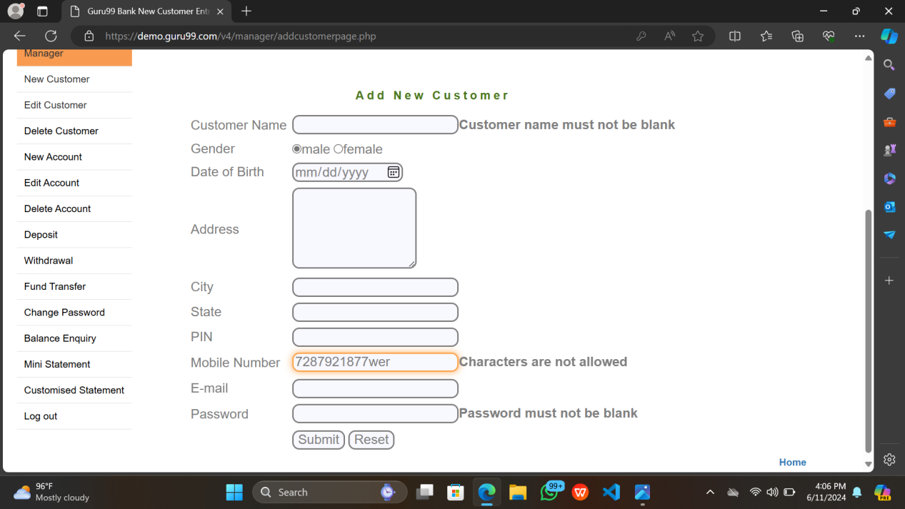

Actual Result :- Characters aren’t allowed

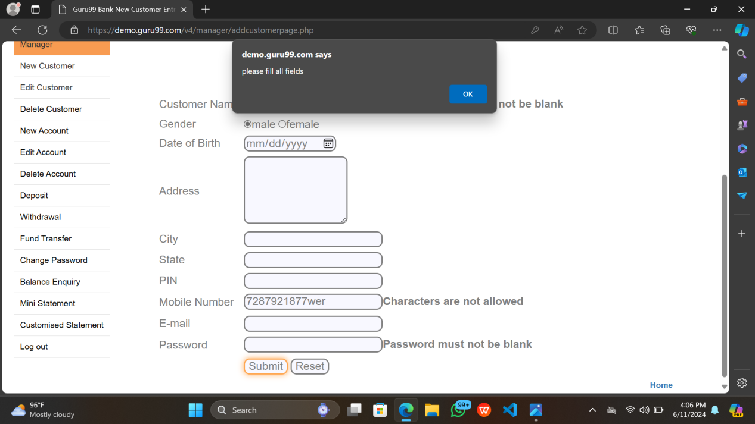

Error message :- Please fill all the details .

TC_007 :- Validating the new customer page by giving invalid PIN

Expected result :- Error message should be displayed .

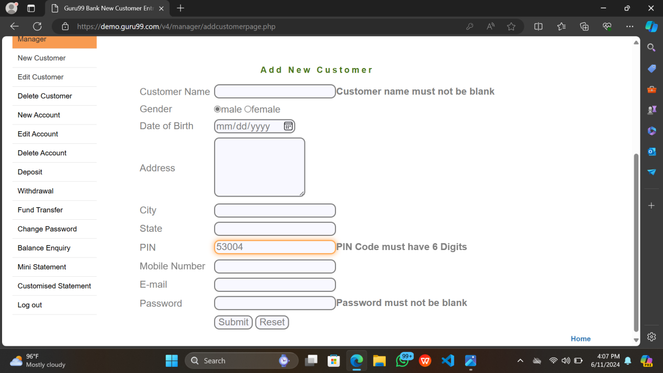

Actual Result :- Pin Code must have 6 digits .

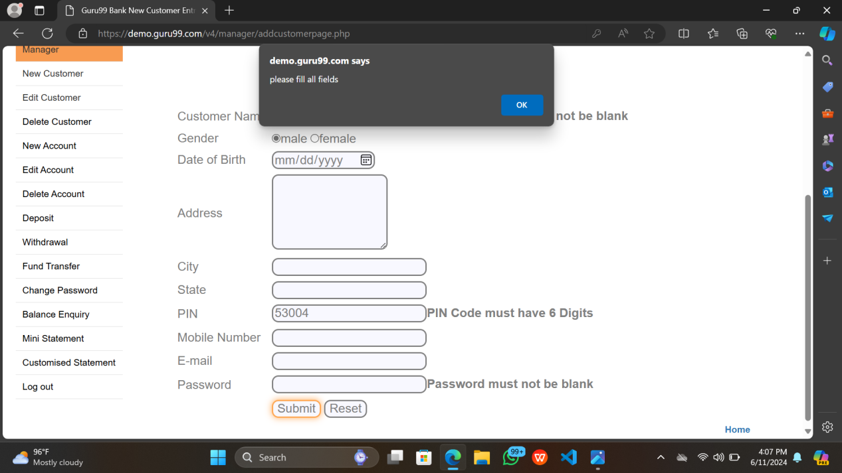

Error message :- Please fill all the details .

TC_008 :- Validating the new customer page by giving invalid mobile number with extra digits

Expected result :- Error message should be displayed .

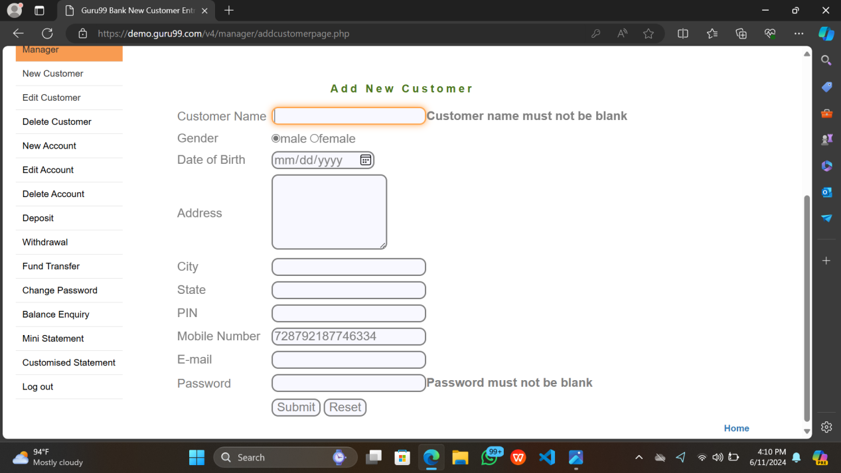

COMMENT :- It’s an error

PRIORITY :- Medium

SEVERITY :-Major

Actual Result :- Its accepting the data which is invalid.

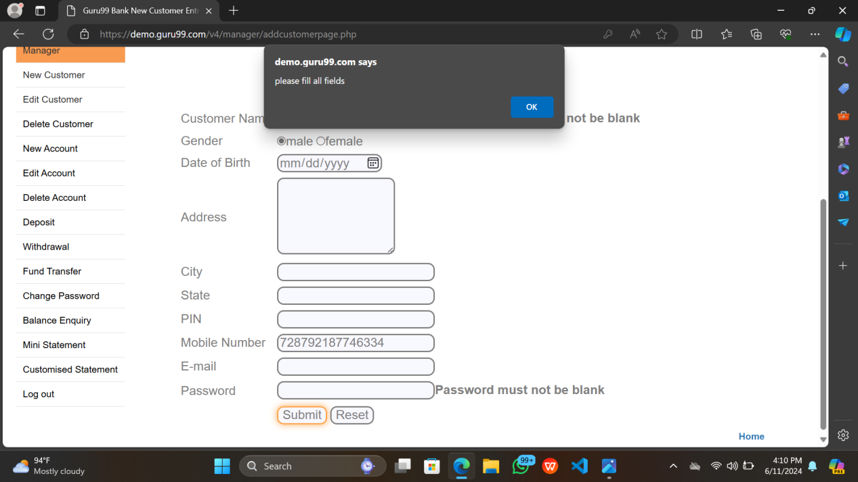

TC_009 :- Validating the new customer page by giving invalid Email-id

Expected result :- Error messsage should be displayed .

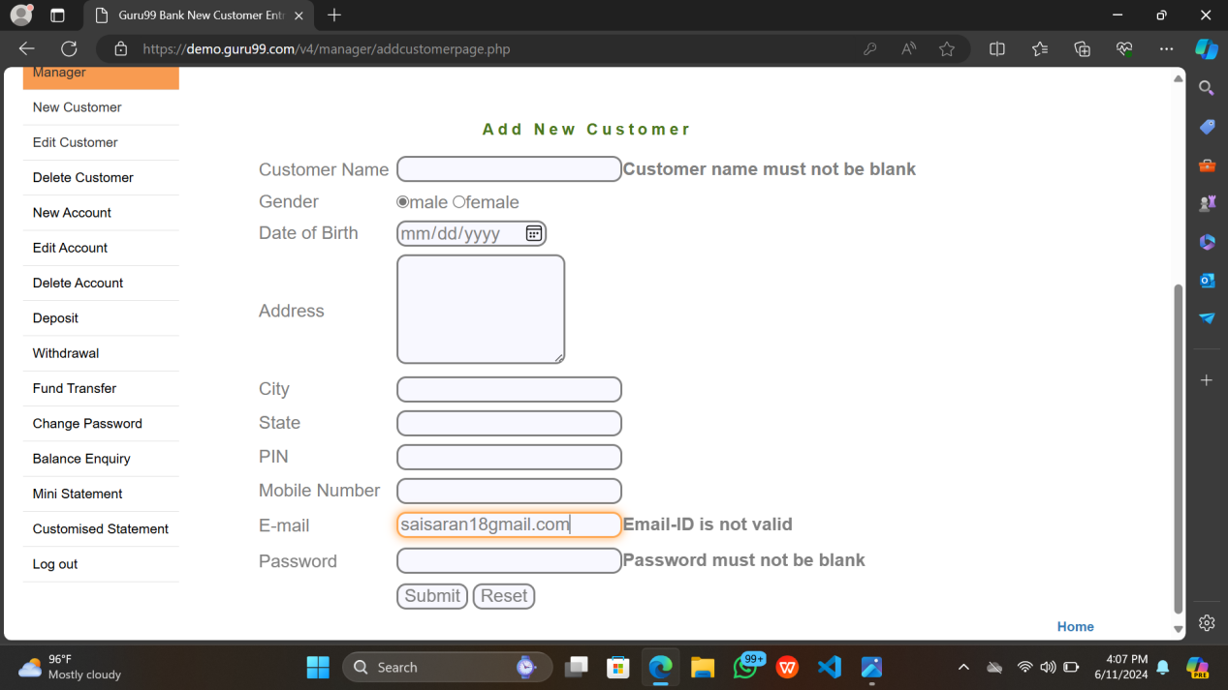

Error message :- Please fill all the details .

TC_010 :- Validating the new customer page by giving invalid Number by giving 9 digit mobile number

Expected result :- Error message should be displayed .

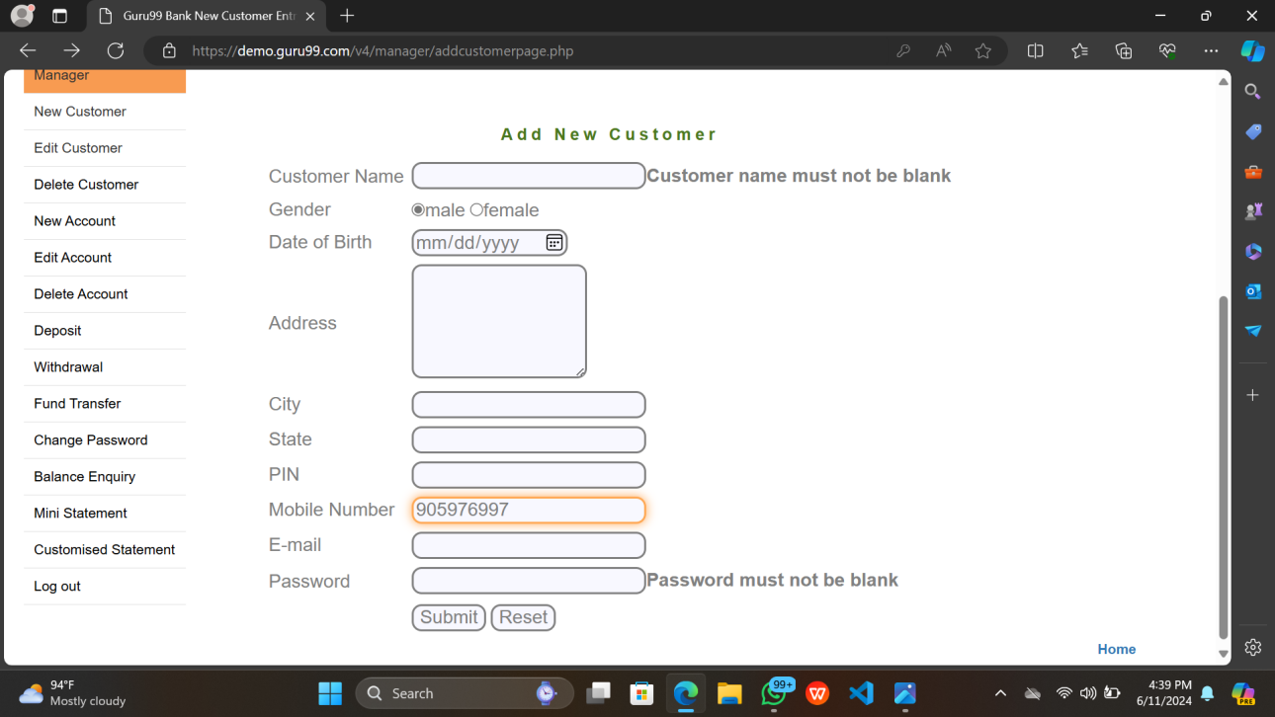

Actual Result :- Its accepting the data which is invalid.

COMMENT :- It’s an error

PRIORITY :- Medium

SEVERITY :-Major

TC_011 :- Validating the new customer page by giving invalid Birth date

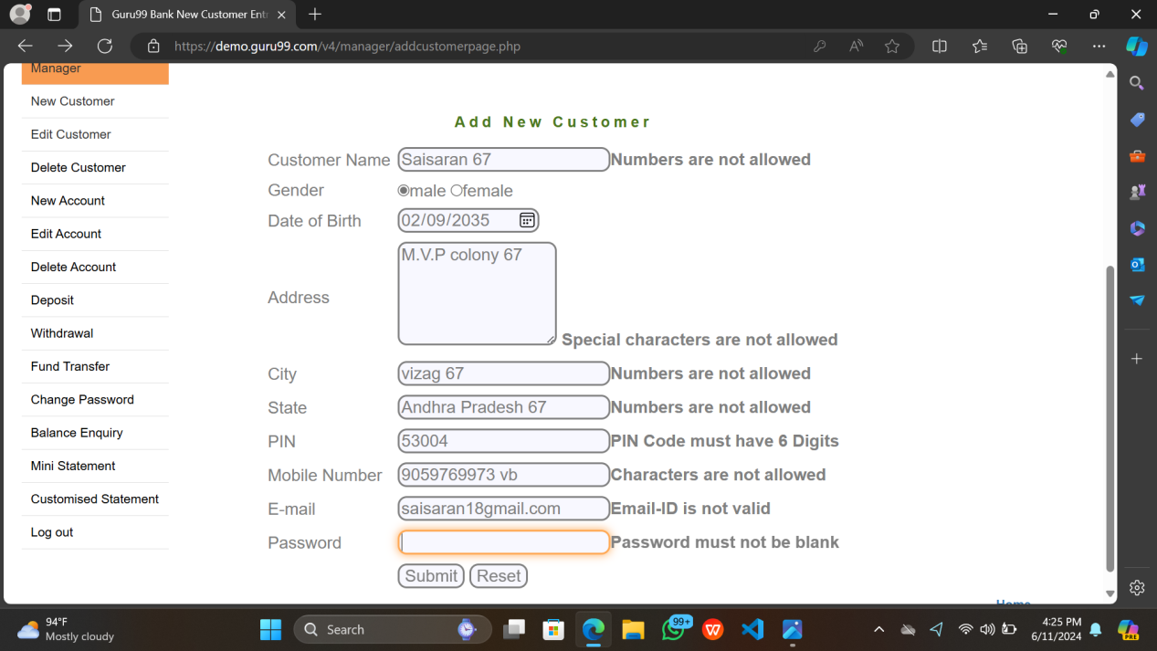

Expected result :- Error message should be displayed .

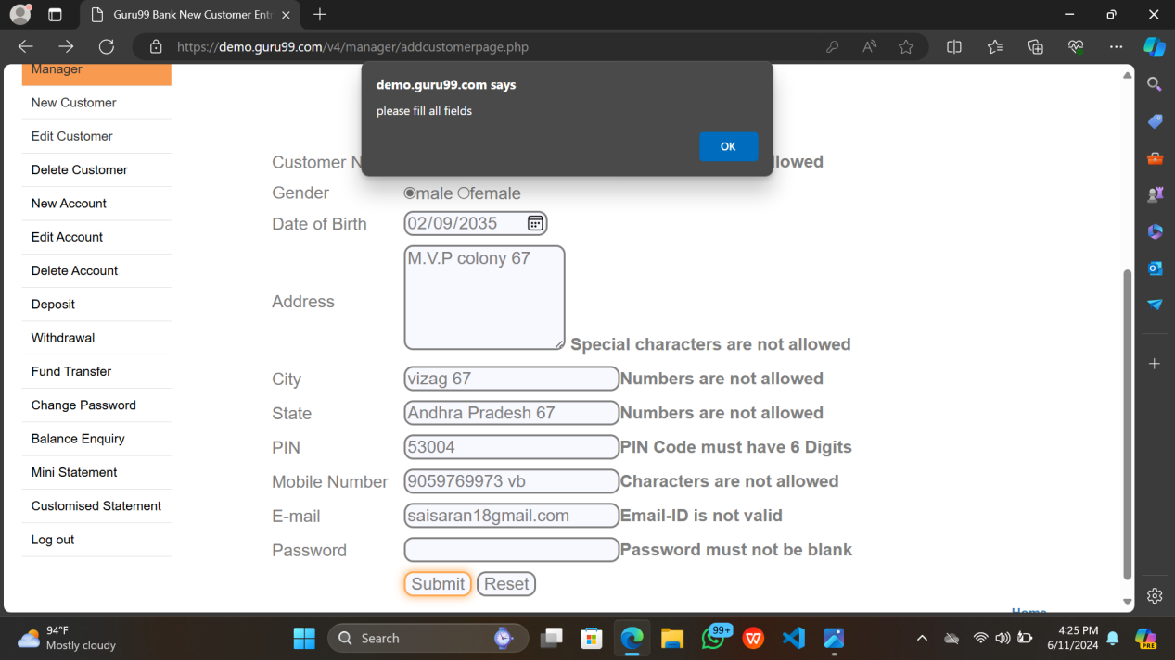

Actual result :- Its accepting the data which is invalid

COMMENT :- It’s an error

PRIORITY :- Medium

SEVERITY :-Minor

TC_012 :- Validating the new customer page by giving invalid inputs

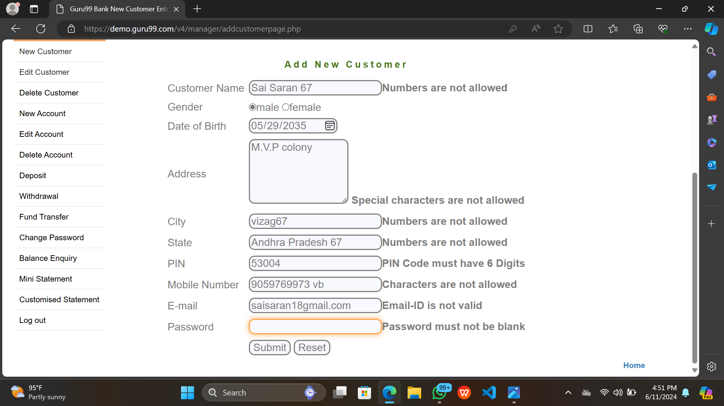

Expected result :- Error message should be displayed .

Actual result :- Numbers aren’t allowed .

Pin code must have 6 digits

Characters aren’t allowed in mobile number

Email is invalid .

TC_013 :- Validating the new customer page by giving valid inputs

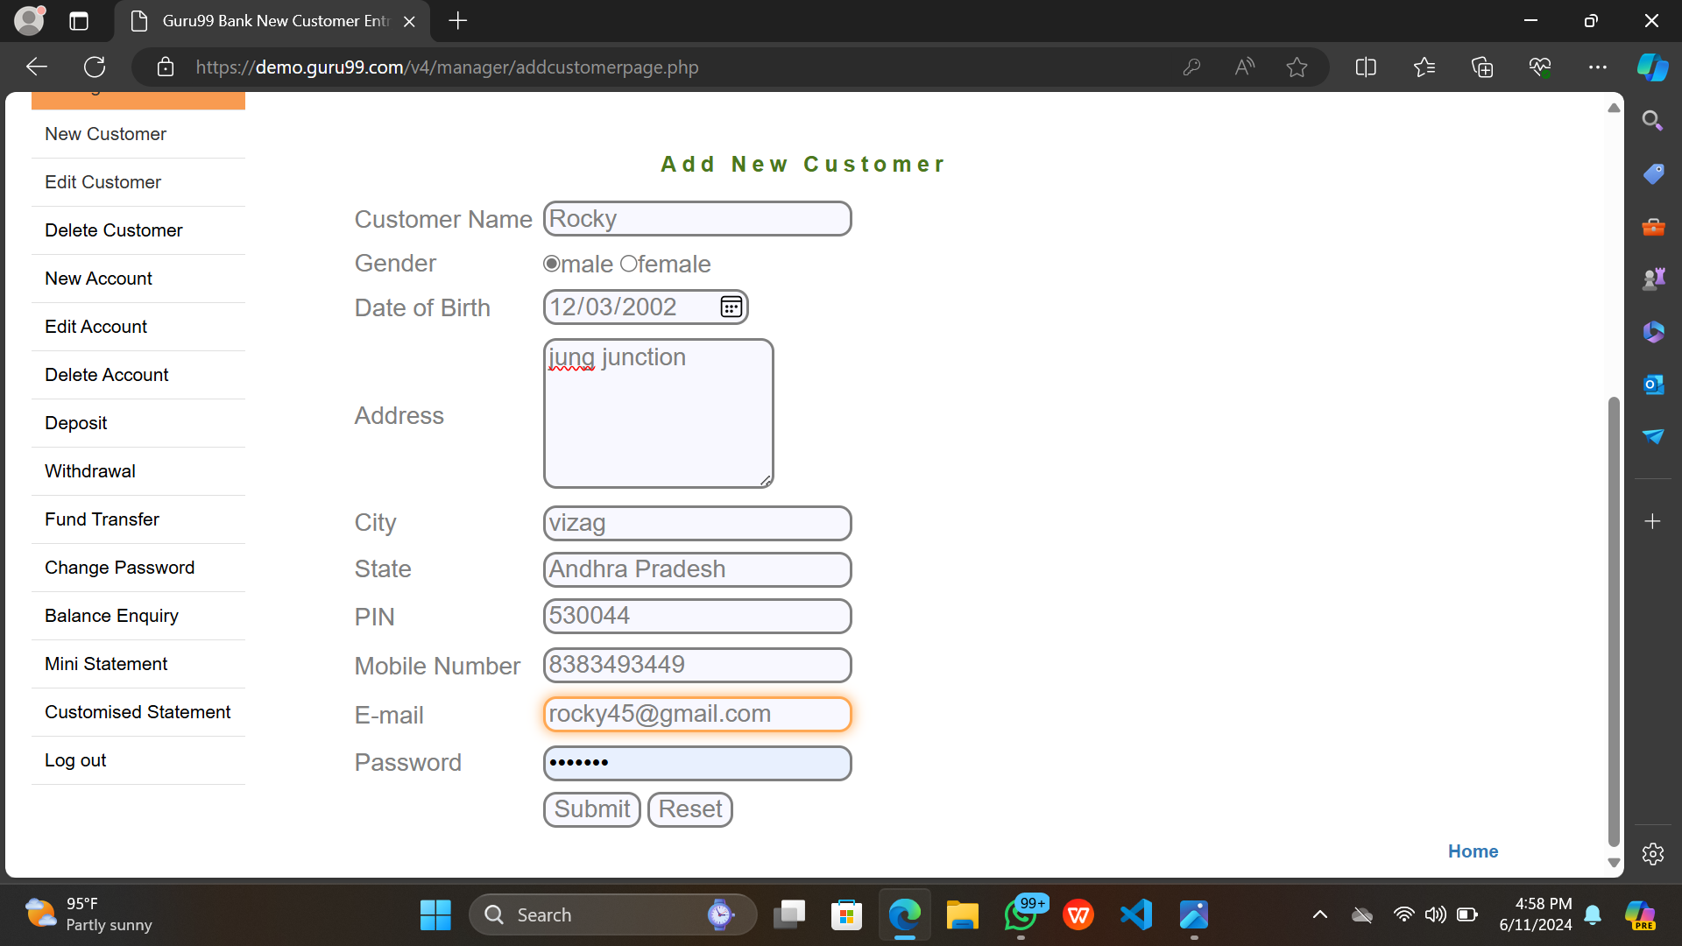

Expected result :- Customer details should be displayed in a table

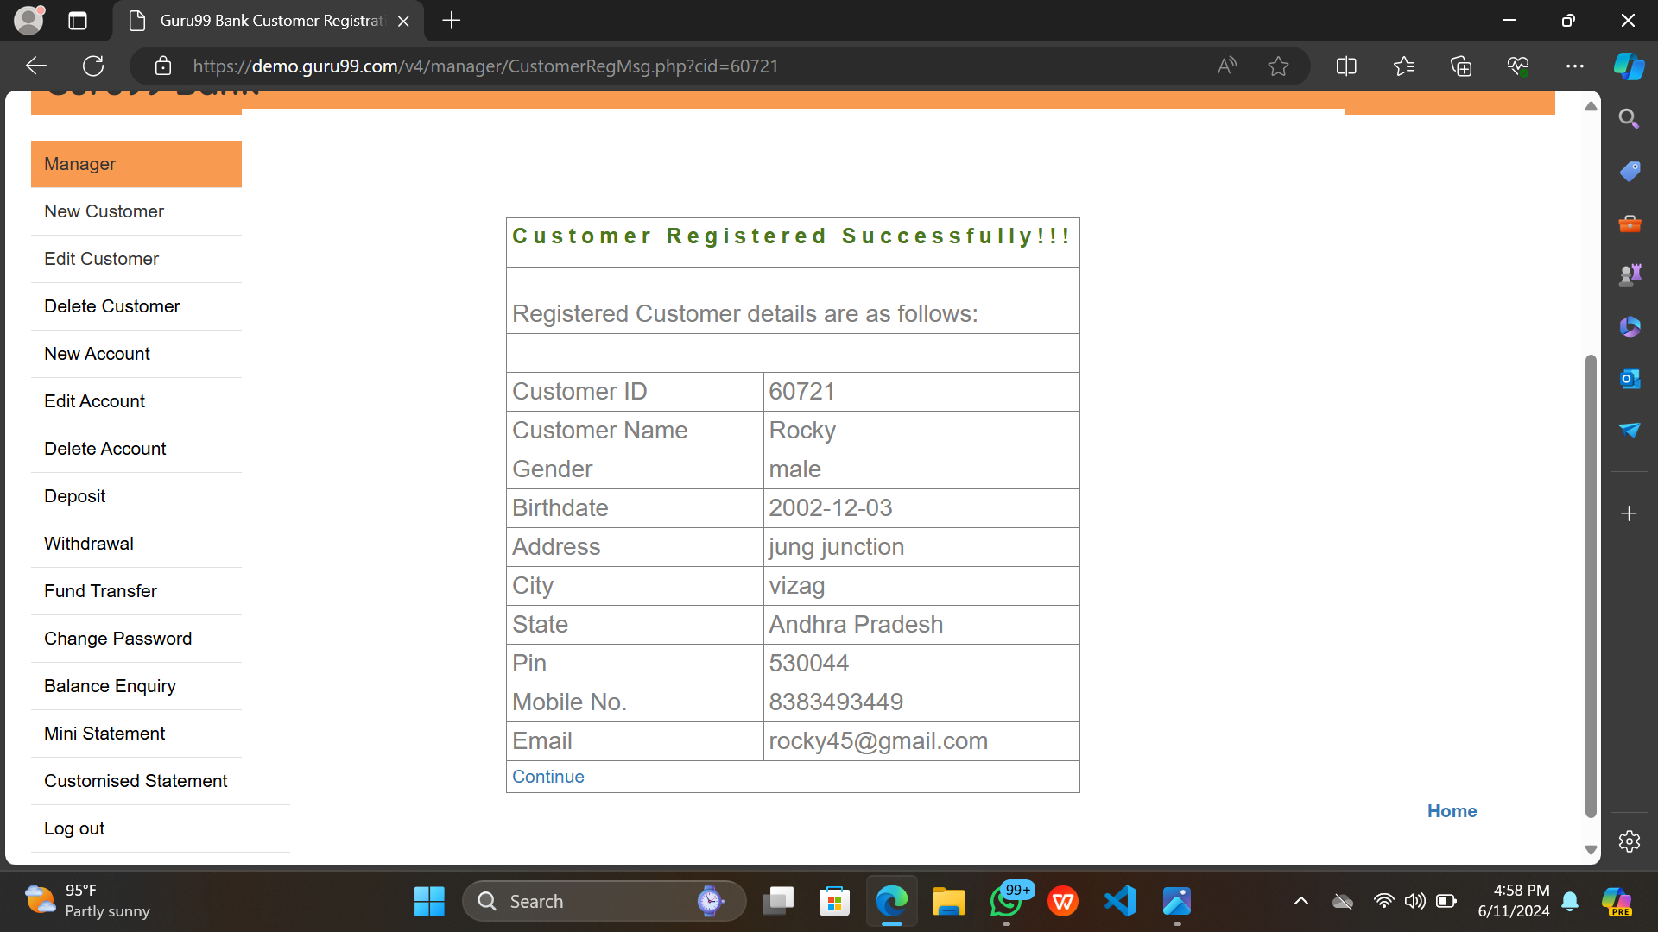

Actual result :- Customer result displayed in a table

TC_014 :- Checking Reset and Submit button .



1. The above customer details are invalid
2. Click on the reset button

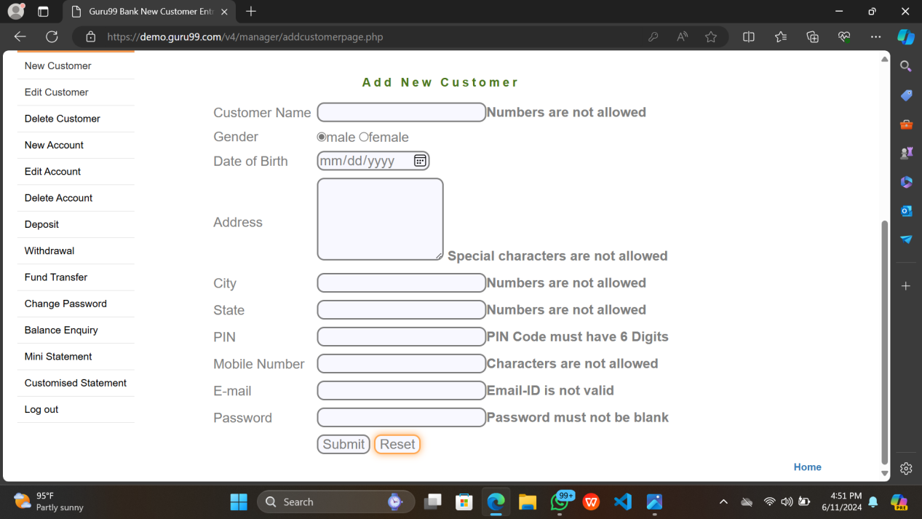

1. Now give valid inputs



1. Click on submit button.



Customer data displayed in a table.